**ASR 5536: JNJ LDC – WMS**

Refer Request 5536.doc

Updated: [2015.08.25]

**WMS Changes:**

# JNJ Orders Import

Drop time format = HHMM

Requestor

* 1. **Import MD** – user manual add “DropTime” and Requestor column in raw report file
  2. **Import DI** - user manual add “DropTime” and Requestor column in raw report file

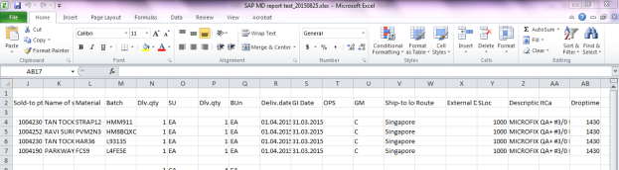

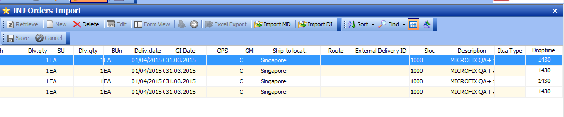

* 1. **~~Import DI~~** ~~– User input DropTime in WMS screen~~

1. ~~When click on [Import DI] – system prompt to input “Drop time”~~

~~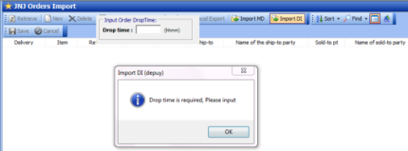~~

1. ~~Input Drop time on the screen:~~
2. ~~After input Drop time, click [Import DI] once again.~~

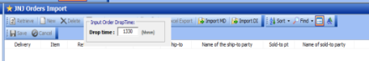

1. ~~Depuy DN upload file remain no change.~~

# JNJ Orders Maintenance

* Added Drop time and Requestor fields
* Both fields set as Mandatory fields.

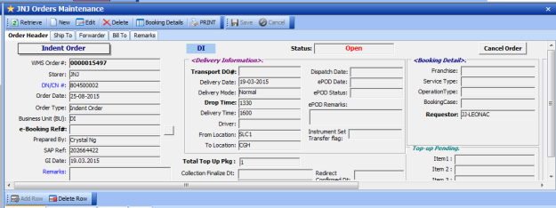

## Requestor list:

Medic sales reps maintain in -> **User code lookup**:

**List name = JNJMDSALES**

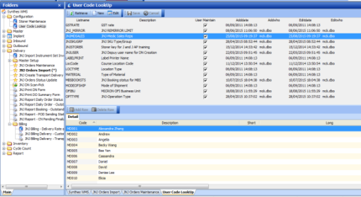

“Requestor” column dropdown list in Orders maintenance

Will be filtered by BU – MD or DI

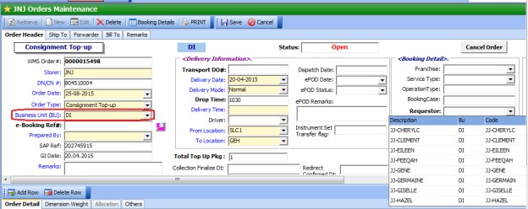

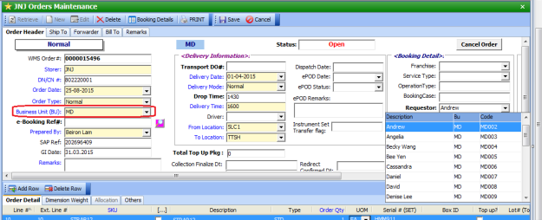

## Depuy Order – populate requestor field in [JNJ New booking (updated)] Screen:

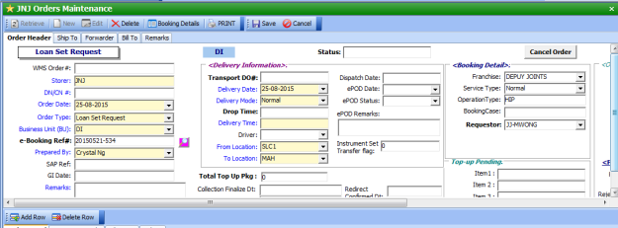

# JNJ Report Daily Order Status Report

– add drop time and requestor fields.

